**Labs:**

|  |
| --- |
| Image Tools |
| Image Manager |

Image Tools

Directions

In this program you will be provided with a project that you need to modify to complete the lab. Your task will be to write and test all the methods in the ImageTools file.

**Directions for completing this lab:**

1. Write a method in the ImageTools file
2. Go to the TestingWindow file
3. Uncomment the line that corresponds to the method you have written.
4. Run the program the and verify that the method worked as intended
5. Repeat steps 1-4 until all the methods have been written and tested

When you are done your program should display the following:

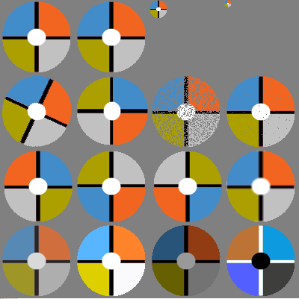

Rubric

|  |  |
| --- | --- |
| Points | Task |
| 5 | Load |
| 5 | Copy |
| 5 | Copy With Transparency |
| 10 | Has Transparency |
| 5 | Scale 1 |
| 5 | Scale 2 |
| 10 | Rotate |
| 10 | Flip |
| 10 | Blur |
| 10 | Invert Color |
| 5 | Remove Pixels 1 |
| 5 | Remove Pixels 2 |
| 5 | Fade |
| 5 | Light by % |
| 5 | Darken by % |

Image Manager

Directions

In this program you will be provided with a project that you need to modify to complete the lab. Your task will be to write and test all the methods in the ImageManager file. Use your ImageTools class to load your images.

Your program will use the loadImages method to load the images map. The load images method uses the other methods in the file for various types of loads.

The ImageList.txt file will be read by your loadImages method to determine what images need to be loaded and how. Each line in the file tells you what image needs to be opened and how it is to be read and what the image(s) are to be named. The first word of a line will tell what kind of load will be occur.

**Types of loads:**

|  |  |
| --- | --- |
| Type / Format | Description |
| Single  Format:  single,key,fileName.extension  Example:  single,axe,bigAxe.jpeg | Key – Key value for the MapEntry  FileName.extension – file name |
| Strip Named by Location  Format:  SNbL,number columns,key,fileName.extension  Example:  SNbL,3,man_walking,walker.png | Number columns – number of sub images  Key – Key value for the MapEntries  (each key name will be followed by a numer 0 to number columns -1)  FileName.extension – file name |
| Grid Name by Location  Format:  GNbL,number columns,number rows , key,fileName.extension  Example:  GNbL,2,2,dog,dog.png  Example Name: dogr0c1 | Number columns – number of columns  Number rows – number of rows  Key – Key value for the MapEntries  (each key name will be followed by r, then the row number, then c and then the column Number)  FileName.extension – file name |
| Strip Specified Name  Format:  SSN,number columns,keys,fileName.extension  Example:  SSN,3,man_standing,man_left_leg_out,  man_right_leg_out,walker.png | Number columns – number of sub images  Keys – The keys will be listed off  FileName.extension – file name |
| Grid Specified Name  Format:  GSN,number columns,number rows, column,keys,fileName.extension  Example:  GSN,2,2,dog_up,dog_left,dog.right,dog_down,dog.png | Number columns – number of columns  Number rows – number of rows  Key – The keys will be listed off FileName.extension – file name |

**When your program is done it should cycle the following images:**



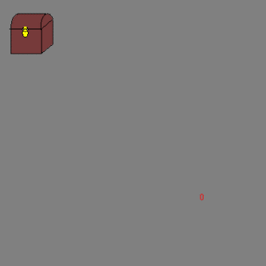

Rubric

|  |  |
| --- | --- |
| Points | Task |
| 60 | Load Images |
| 10 | Load Image |
| 10 | Load Image 2 |
| 5 | Get Image |
| 5 | Remove Image |
| 10 | Get Keys |